PEOPLE VISITING THE RESERVE 2009

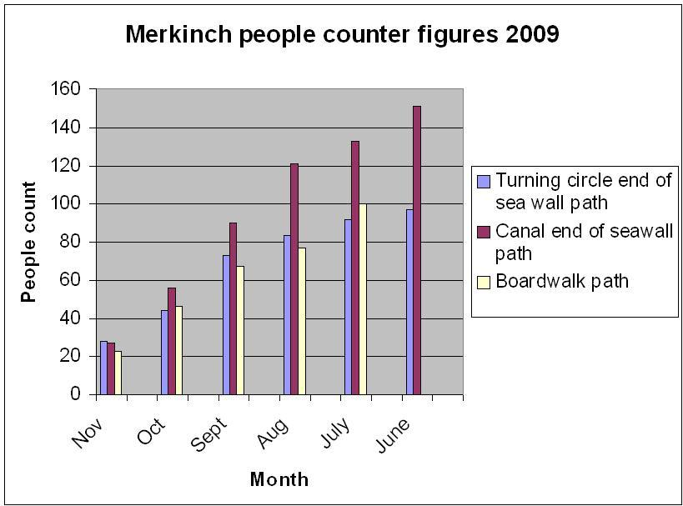

This is a copy of the figures showing the readings taken from special footfall counting mats placed at strategic points around the reserve.

There are no readings for the boardwalk in June as the mats hadn’t been installed yet. Also no readings were taken in December due to being unable to retrieve readings because of weather.

